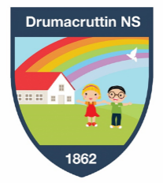
Drumacruttin National School
Open Day
Friday 9th February 2024
1.00pm – 4.00pm
We offer small class sizes and individual teaching and learning experiences for your child.
Come and see for yourself!!
Our enrolment pack is available from the school office or can be downloaded from our website.

Further details available
from Dawn Hutchinson, Principal
047 71186
drumacruttinns@mail.com
Please feel free to visit our website:
www.drumacruttinns.ie

Drumacruttin National School,
Dunraymond, Co.Monaghan.
H18 YD83
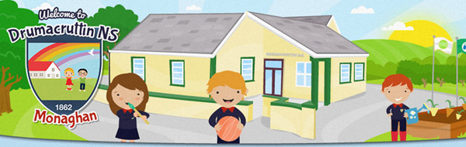
Open Day Friday 9th February 2024
Located on the main Monaghan to Ballybay road, Drumacruttin NS offers a small-school, child-centred learning experience for your child.

Visit our website:
www.drumacruttinns.ie

With highly experienced teaching and support staff and our small class sizes we provide high quality education tailored to meet the individual needs of your child within a safe and caring environment.
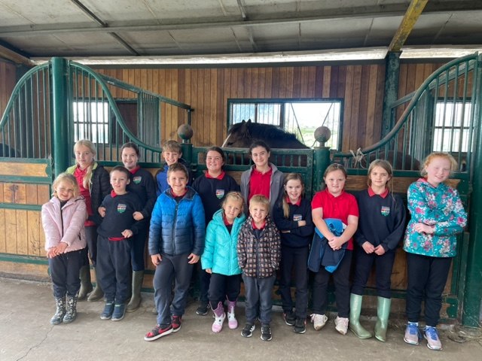

We aim to see each child in our care grow and flourish to reach their potential. We endeavor to equip them with the confidence and skills they will need to become life-long learners.

So why choose Drumacruttin NS for your child?
We Offer:
- A ‘BIG’ family atmosphere where all the children know each other, look out for each other and are friends.
- A Christian ethos where everyone is welcome, equal and valued.
- Small class sizes.
- Experienced, professional, committed staff.
- Individualised teaching and learning.
- A bright, stimulating learning environment.
- A strong emphasis on each pupil reaching their potential in Literacy and Mathematics
- A broad, balanced, experiential, skills based curriculum.
- Special Education Support from experienced SET teachers.
- Our Junior Infants can stay at school until 3pm.
- A fun, enjoyable and stimulating learning experience from Junior Infants through to sixth class.
- Local childcare facilities within walking distance of the school. (Children can be collected and taken to their childcare after school)

