Drumacruttin National School
Ballybay road
(6km from Monaghan Town)
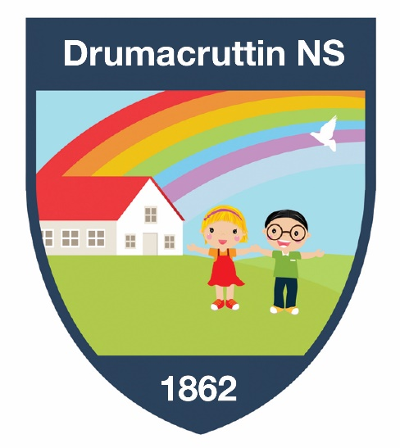
Open Day
Friday 9th February 2024
1.00pm – 4.00pm
We offer small class sizes and individual teaching and learning experiences for your child.
Come and see for yourself!

Our enrolment pack is available from the school office or can be downloaded from our website.

Further details available
from Dawn Hutchinson, Principal
Phone: 047 71186 Email: drumacruttinns@mail.com

Please feel free to visit our website: www.drumacruttinns.ie

